ALTAGAMMA DIGITAL AWARDS 2020:
GUCCI, BURBERRY, PRADA, DIOR AND MONCLER ARE WINNERS
Fourth edition of the awards founded by Altagamma in collaboration with Contactlab

Milan, 4 December 2020 – This morning saw the announcement of the winners of the fourth edition of Altagamma Digital Awards, accolades given to Personal Luxury brands that stand out for their digital leadership. The 2020 edition was organised in partnership with the National Chamber of Italian Fashion.
The winners of this edition are Gucci, Burberry, Prada, Dior and Moncler.
The prizes are awarded on the basis of data collected and analysed in the 2020 edition of the Digital Competitive Map, a proven tool for evaluating the digital positioning of luxury brands developed by Contactlab, which this year measured the performance of 44 brands based on 271 parameters.
The prizes fall into two categories: Best Digital Offer and Best Customer Relations, with awards in each for the Best in Class and Best Improver, plus a Special Award for the most outstanding performance in the past three editions.
The Best in Class 2020 prize winners are Burberry (best digital offer) and Gucci (best customer relations); the Best Improver 2018-2020 goes to Prada (best digital offer) and jointly to Dior and Moncler (best customer relations) for their progress in the area over the past two years.
Gucci was also given a Special Award for being top in digital excellence for the past three years.
In the words of Stefania Lazzaroni, General Manager of Altagamma: “The pandemic has led to an acceleration of online sales of personal luxury goods, which have grown by 12% to 23% of total sales in 2020; Digital is turning from a channel for sales and communication into an environment in which today’s - younger - consumers can live an immersive experience with the brand. With the Altagamma Digital Awards, created with Contactlab, we intend to monitor the evolution of the digital ecosystem of Personal Luxury Goods on the basis of a very broad set of parameters that offers an opportunity for comparison and analysis on which are the most useful and effective tools to manage social media and online activity”

The "Digital in the Post-Covid Era" study, presented by Antonio Achille, Senior Partner and Global Head of Luxury at McKinsey & Company, highlighted the acceleration that the pandemic has given to the use of digital in the world of Personal Luxury Goods: 1 in 4 consumers bought online for the first time, and 3 out of 4 rated the shopping experience positively. Online penetration is expected to grow by about + 20% over the next two years and the consumer will become increasingly demanding. This requires particularly challenging adaptive strategies from brands: extreme care in the collection and systematization of data, a more agile and rapid marketing model in execution, an extreme personalization of the offer and communication and an increasing attention to the authenticity of the storytelling.

In the year of Covid-19, research by Contactlab indicated a strong acceleration in the online presence of all brands, particularly through the development of tools to facilitate online shopping (direct and indirect presence on e-stores; product finder tools; options for digital gifting with split payments etc); the involvement of stores and sales assistants in virtual environments (for example, the option to book virtual appointments and access support through live chat or video calls); the adaptation of content conveyed via email marketing to the circumstances of the pandemic and lockdown (getting close to users with dedicated content or special initiatives, links for booking virtual appointments, phone numbers for sales assistants). There was also evidence of an increase in the use of augmented reality to “make up for” customers’ inability to leave the home, with virtual visits to stores and 3D viewing of products purchased and their packaging.
“The luxury sector has been extremely reactive in its response to the Covid-19 catastrophe, accelerating its e-commerce presence on all direct and indirect channels and developing effective tools to facilitate the choice and purchase of goods online”, says Marco Pozzi, Senior Advisor at Contactlab and author of the study. The valuable knowledge of sales assistants has also been rapidly re-used to promote virtual engagement. It is enormously gratifying for Italian fashion that the six outstanding brands shortlisted include Gucci, Valentino and Bulgari. Furthermore, Prada, Moncler, Armani, Versace and Dolce&Gabbana emerge as brands which have most improved their digital performance in 2020”.

Below are the winners of the Altagamma Digital Awards 2020 and the reasoning behind each prize.

BEST DIGITAL OFFER - Best in Class 2020

Burberry stands out for the most widespread presence on e-commerce platforms, both directly (not only Russia, the Gulf States and China, but also Poland, Turkey, Qatar, Kuwait, Singapore and Malaysia) and via e-tailers (including 24Sevrès, Luxury Pavilion and Ssense) and luxury online department stores (including Isetan Mitsukoshi in Japan and TSUM in Russia).
Moreover, it has expanded its online range and offers the most extensive content localisation on the web (including the choice of 11 languages for the US website) and through email marketing (including emails in Russian, Portuguese and traditional Chinese).
Lastly, we find that the company has implemented its presence on social media platforms, including in Asia, and geolocated its Facebook account.

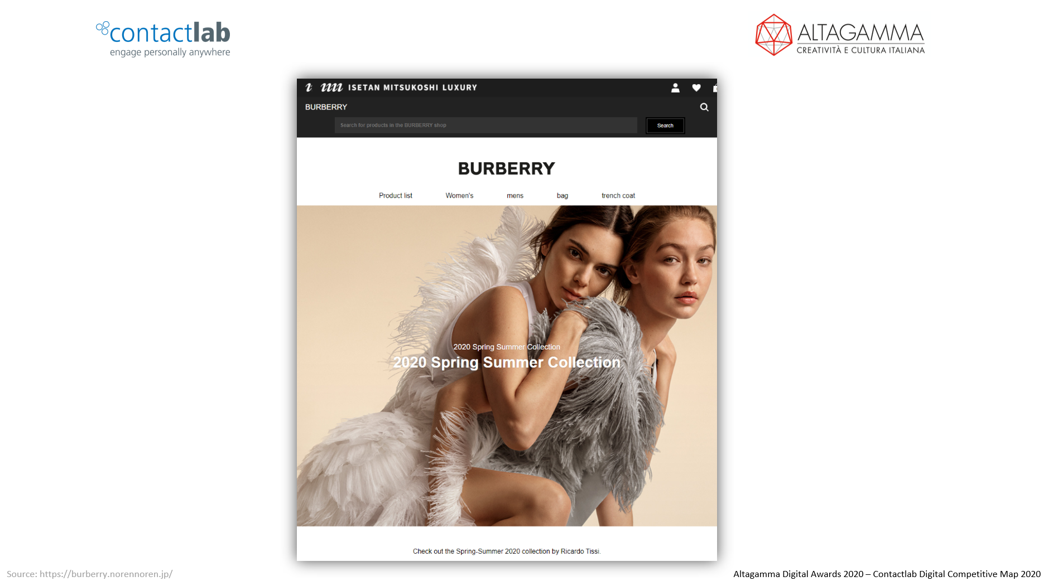
The sample shows how the Burberry range has been added to the Isetan/Mitsukoshi e-shop in Japan

BEST DIGITAL OFFER – Best Improver 2018-2020

The acceleration of Prada's digital transformation and omnichannel approach over the past two years has resulted in a complete redesign of the site's customer experience on an international scale and in the opening of new e-commerce markets (Brazil, Singapore and Korea in 2020 ).

The brand has also focused on localization and personalization of content and has further strengthened its digital communication strategy through the full use of social channels (in some cases by opening new ones), in the various geographies.

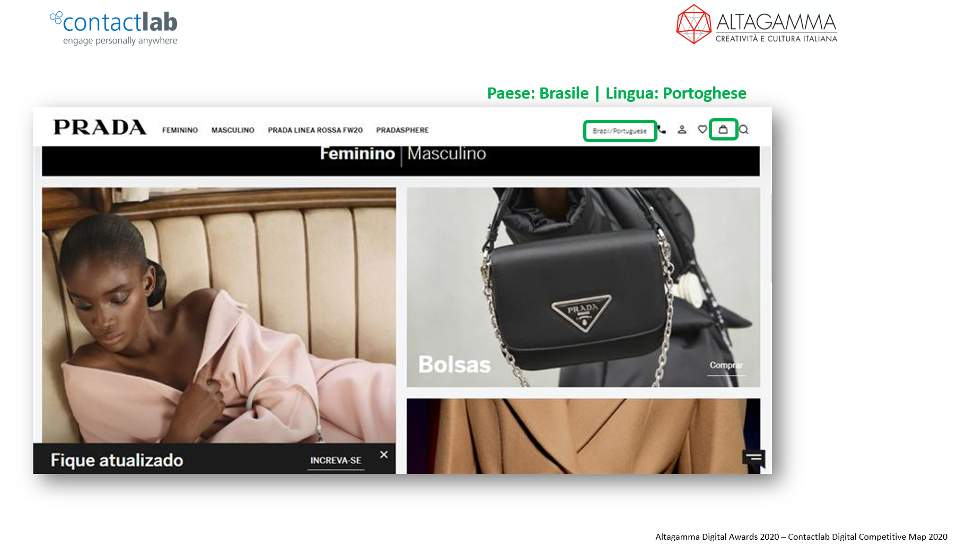
The example from Prada shows its addition to Brazilian e-commerce

BEST CUSTOMER RELATIONS: Best in Class 2020

Gucci stands out for the excellence of its navigation and user experience during online shopping, for the high quality and variety of content for Digital Direct marketing, in which the company has effectively become a benchmark, but above all for its constant desire to experiment and innovate online (for example, through an app with Augmented Reality, eco-packaging, digital gifting with split payments, emails with links for remote shopping etc).

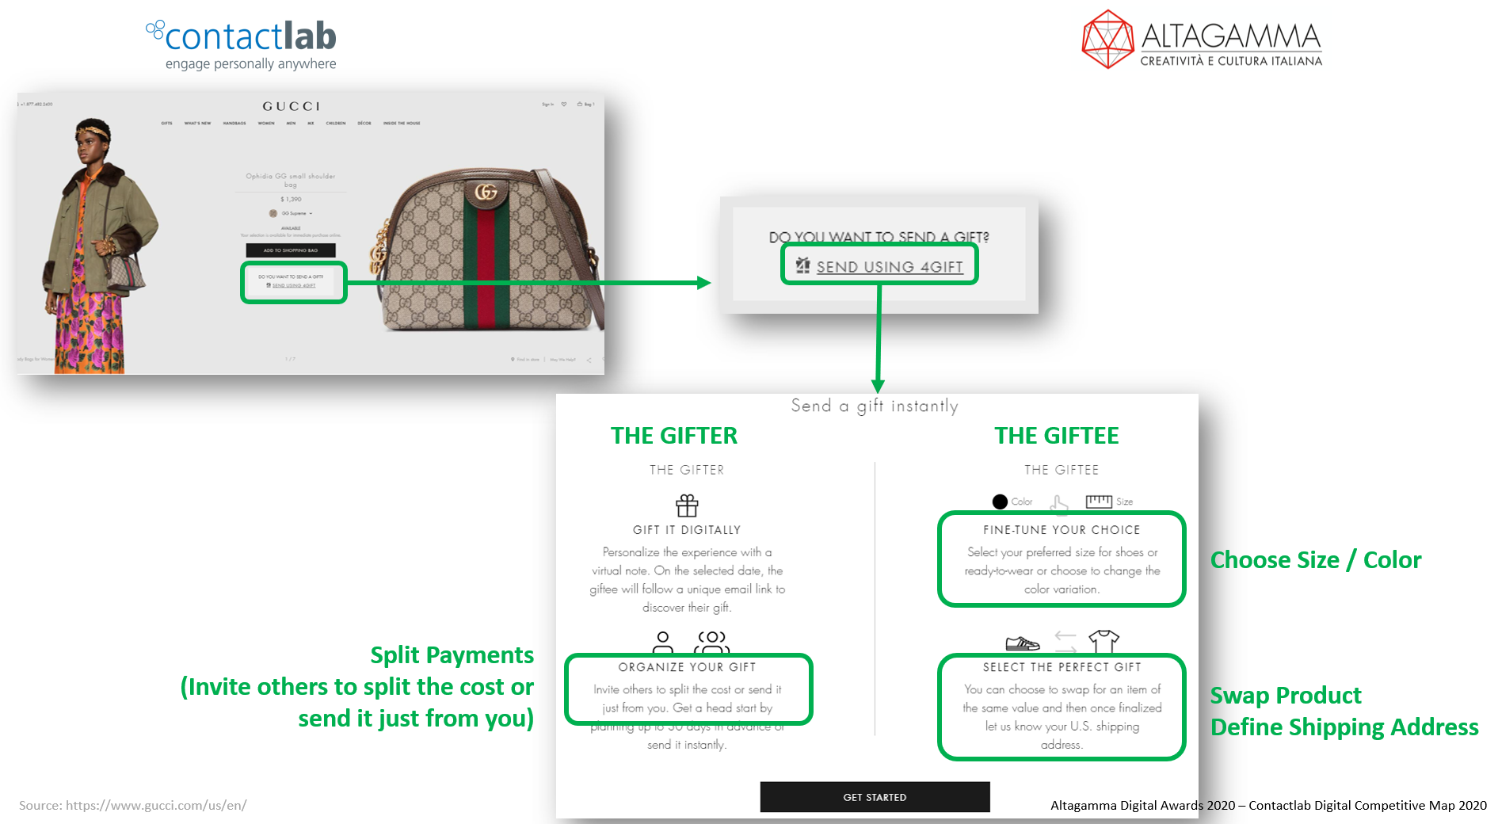Gucci is an excellent example of creativity in the development of user experience for online shopping. Here we see Digital Gifting with Split Payments.

BEST CUSTOMER RELATIONS: Best Improver 2018-2020
joint winner

Dior has worked hard in recent years to improve the user experience of both its e-commerce platform and its website; it has also increased the payment options available online (PayPal, Apple Pay, Bank Transfer). Furthermore, it has introduced several innovative services such as the Facebook chatbot, a virtual perfume store, an app for virtual try-ons of make-up and augmented reality on emails via Instagram, Facebook, Snapchat and web browsers.

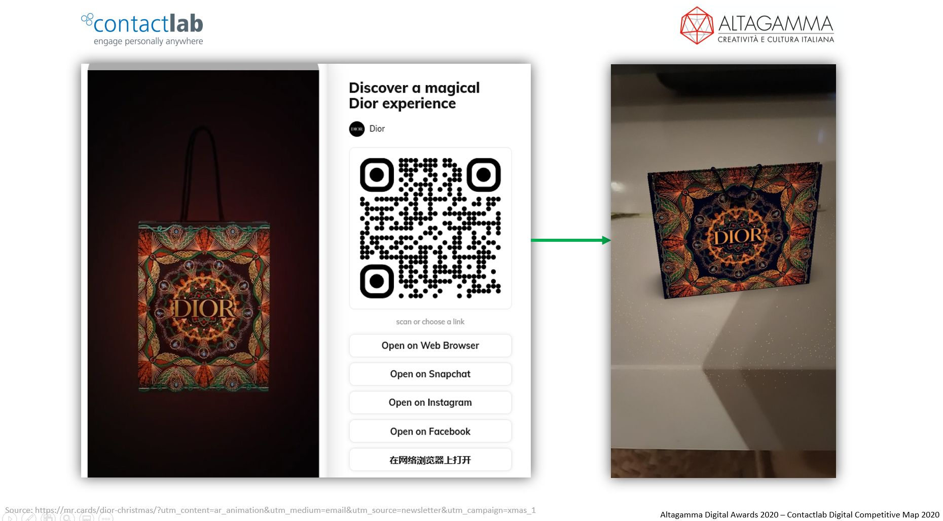

The sample shows the introduction of Augmented Reality by email (via link)

BEST CUSTOMER RELATIONS: Best Improver 2018-2020
joint winner

Moncler has enhanced omnichannel services by including store virtual appointments, expanding online payment and delivery (Next Day, Same Day, Saturday) and return (pick-up and drop-off) options ). It has also invested in the development of in-store digital services, focusing on a full mobile digital experience: digital data collection, mobile payments, endless aisle and mobile after sales. It has also made available to both the client and the client advisor the possibility of making remote sales (buy from home). Finally, it has strengthened the digital interaction with the consumer through digital postcards, live-streaming and digital appointments

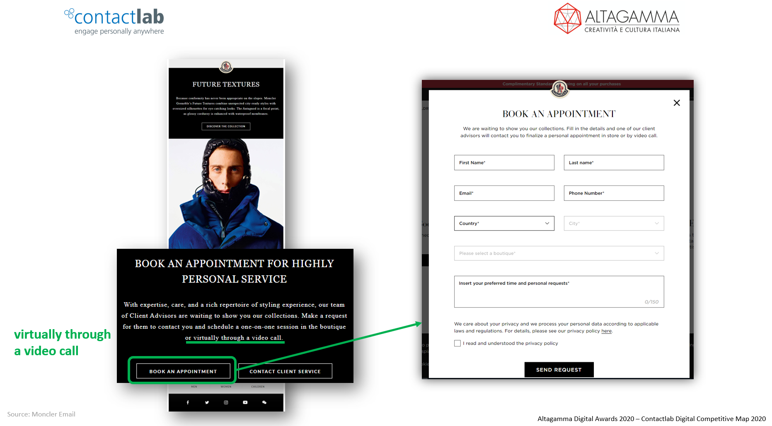

The Moncler example shows how email marketing is an important vehicle for all the new initiatives, such as the option of booking a Virtual Appointment with a simple click on the newsletter

Press contacts:
Altagamma
Edoardo Carloni (Head of Communications) - carloni@altagamma.it - T 02 36636307 - M 3391618463
Giorgio Bocchieri (Communications) – bocchieri@altagamma.it – T 02 36636309 - M 3346853078

Contactlab
Viola Venturelli (PR Manager) - viola.venturelli@contactlab.com - M. +39 348 7822 561

ALTAGAMMA FOUNDATION
Since 1992, the Altagamma Foundation has brought together brands in Italian High-End Cultural and Creative Industries, encouraging growth and competitiveness and simultaneously offering a contribution to the national economic system. The organisation is characterised by its intersectoral representation, and includes all the high-end Made in Italy sectors - fashion, design, food, yachts, automotive, wellness, jewellery and hospitality. The high-end sector in Italy is worth 115 billion euros, employs 400,000 people and acts as a vehicle and ambassador for our values worldwide. www.altagamma.it

CONTACTLAB
Since 1998 we have supplied products and services which help brands to make best use of their Customer Engagement strategies. Our experts work hard to get the best results from technology, whether owned by Contactlab or by third-party suppliers (Salesforce, Oracle, Adobe), in order to build customer engagement programmes that become success stories.
The Contactlab Marketing Cloud expands our market-leading software solution for multi-channel sending with a suite of products for the collection and interpretation of the activities (digital and otherwise) of contacts, segmentation and planning of campaigns and personalising communication, enabling brands to build a one-to-one relationship with their customers.
For more information: https://contactlab.com/it

